* Database Module 11_1
  + Charlie Group
    - Jacob Breault
    - Cameron Frison
    - Skyler Millburn
    - Angela Perkins
    - William Silknitter III

Milestone 3:

We reviewed the information required, and actually needed to make an update to our tables because as written, our trek_history table was flawed: If the trek_history matches the id on the trek_history_id you will only be able to have one person on a trek. Revision is below:

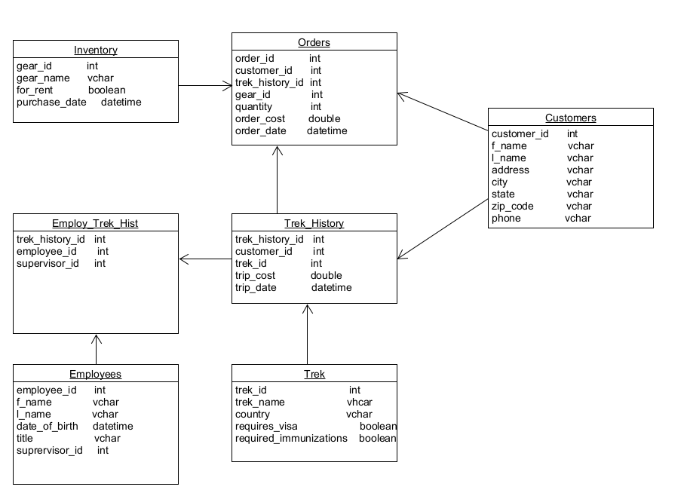

We wrote 4 reports; The three that were part of the Outland Adventures case study, and one that we thought would benefit the business:

1. Inventory Name and Quantity Ordered:
   1. Our report returns the name of the gear, gear ID, and how many pieces were ordered. Getting this information required a SUM of the quantities from the orders table for each of the gear items. The results are below:

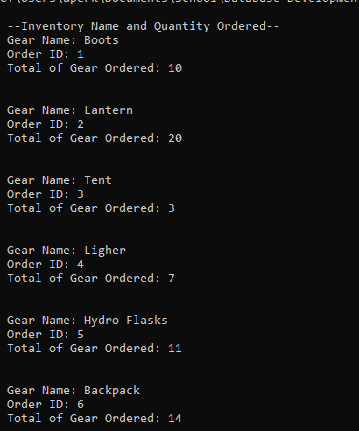

1. Customers on Each Trek
   1. This report gives the trek name, location, date, and number of customers on each track. This required a COUNT of the customer_id to find out how many customers were on each trek.

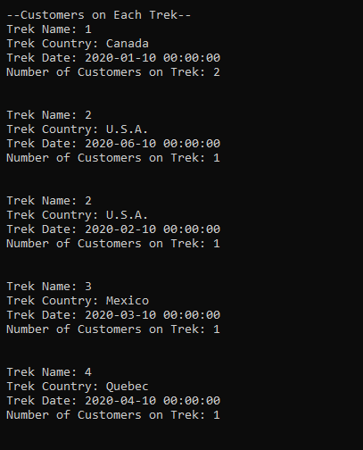

1. Gear Purchase Dates:
   1. We broke this down into two reports; Gear purchased before 2016, and all gear purchase dates. While they return the same fields of Gear ID, Gear Name, and Purchase Date, the gear purchased before 2016 report will help them quickly identify potentially dangerous gear. In Gear purchased before 2016, we used WHERE YEAR to find any inventory that was purchased before 2016.

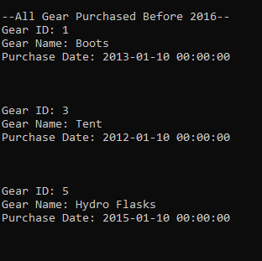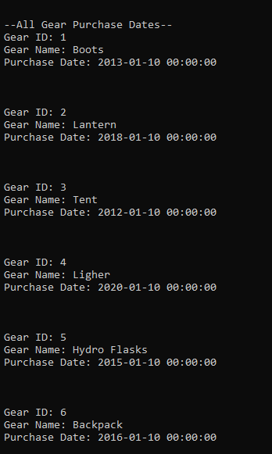

1. How Many Treks and Amount Spent Per Customer
   1. This was a report that we could see adding great value to Outland Adventures! The report returns the customer id, name, how many treks they’ve been on, and how much they’ve spent. We used COUNT to count the trek_history_id for each customer, and SUM of trip cost to see how much each had spent.

